Sierra Method Assignment # 3
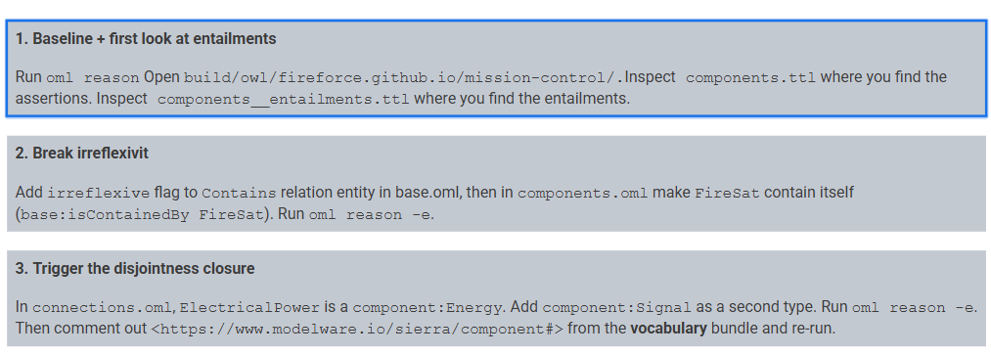

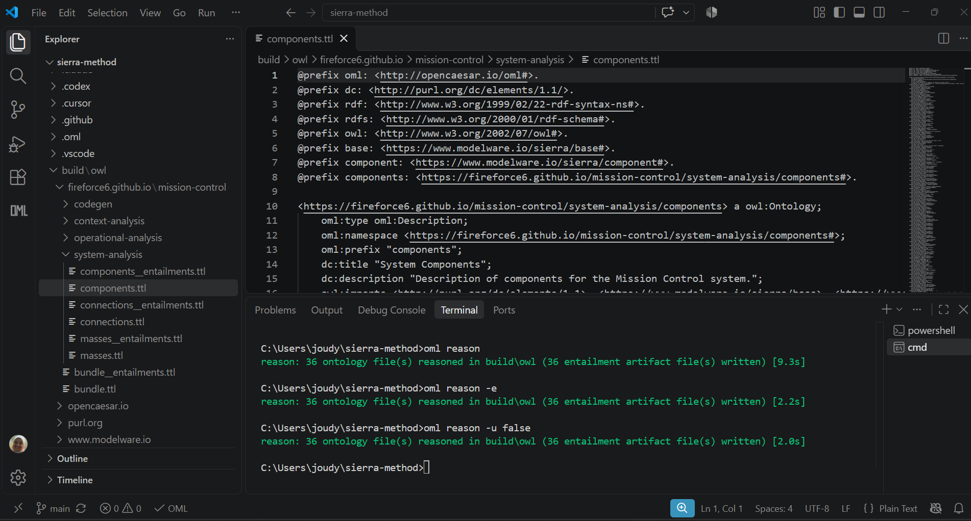
Observations on components.ttl (assertions)
- This file is an OML Description of 176 components, one per a component:Component / oml:type oml:ConceptInstance declaration.
- Each component has a base:description. A few also have an rdfs:label.
- 175 components have exactly one base:isContainedBy link to their parent. Only components:FireSat, the root, has none.
- The hierarchy is formatted as a single tree rooted at components:FireSat, which is the only component with no isContainedBy. Then we have Payload, Platform, and PropulsionSegment.
- The platform splits into ServiceSegment and ElectronicsSegment, and so on down to parts like battery cells and wheel motors. The deepest chains are about 6 levels below FireSat, e.g. FireSat → Platform → ServiceSegment → ADCSSubsystem → ReactionWheelAssembly → ReactionWheel1 → WheelMotor1.
Observations on components__entailments.ttl (entailments)
- This file imports components plus the entailments of the vocabularies. It contains only facts the reasoner derived, and none of the descriptions or isContainedBy statements.
- It adds an inverse relationship where base:contains is inferred from base:isContainedBy. ServiceSegment now contains ADCSSubsystem, PowerSubsystem, ThermalSubsystem and StructuralFrame, although no one wrote that. In total there are 61 container components and 175 contains statements.

Conclusion. The modeler states each relationship once, in one direction, and the reasoner supplies the inverse direction and the type information.

Irreflexive flag in base.oml
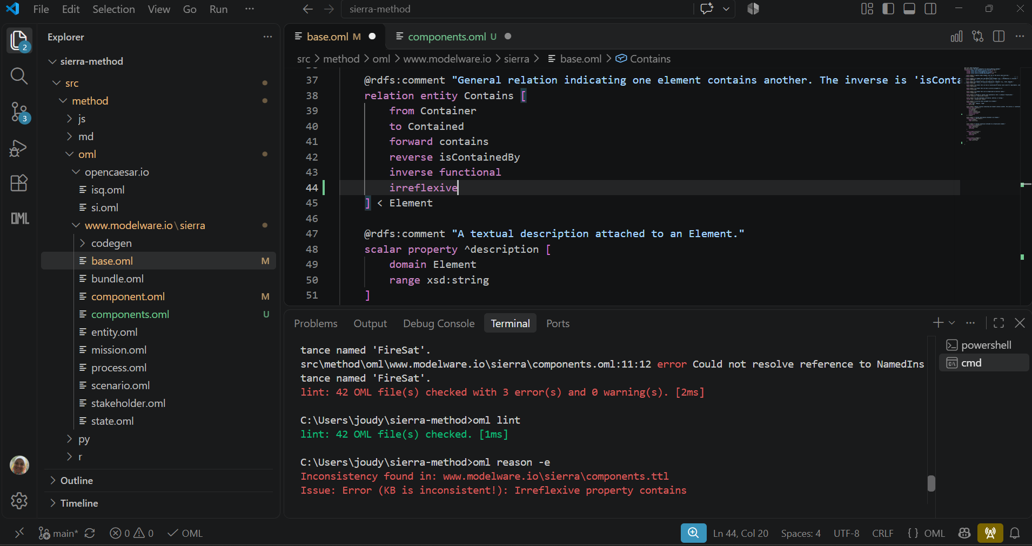
Components.oml: FireSat contains itself
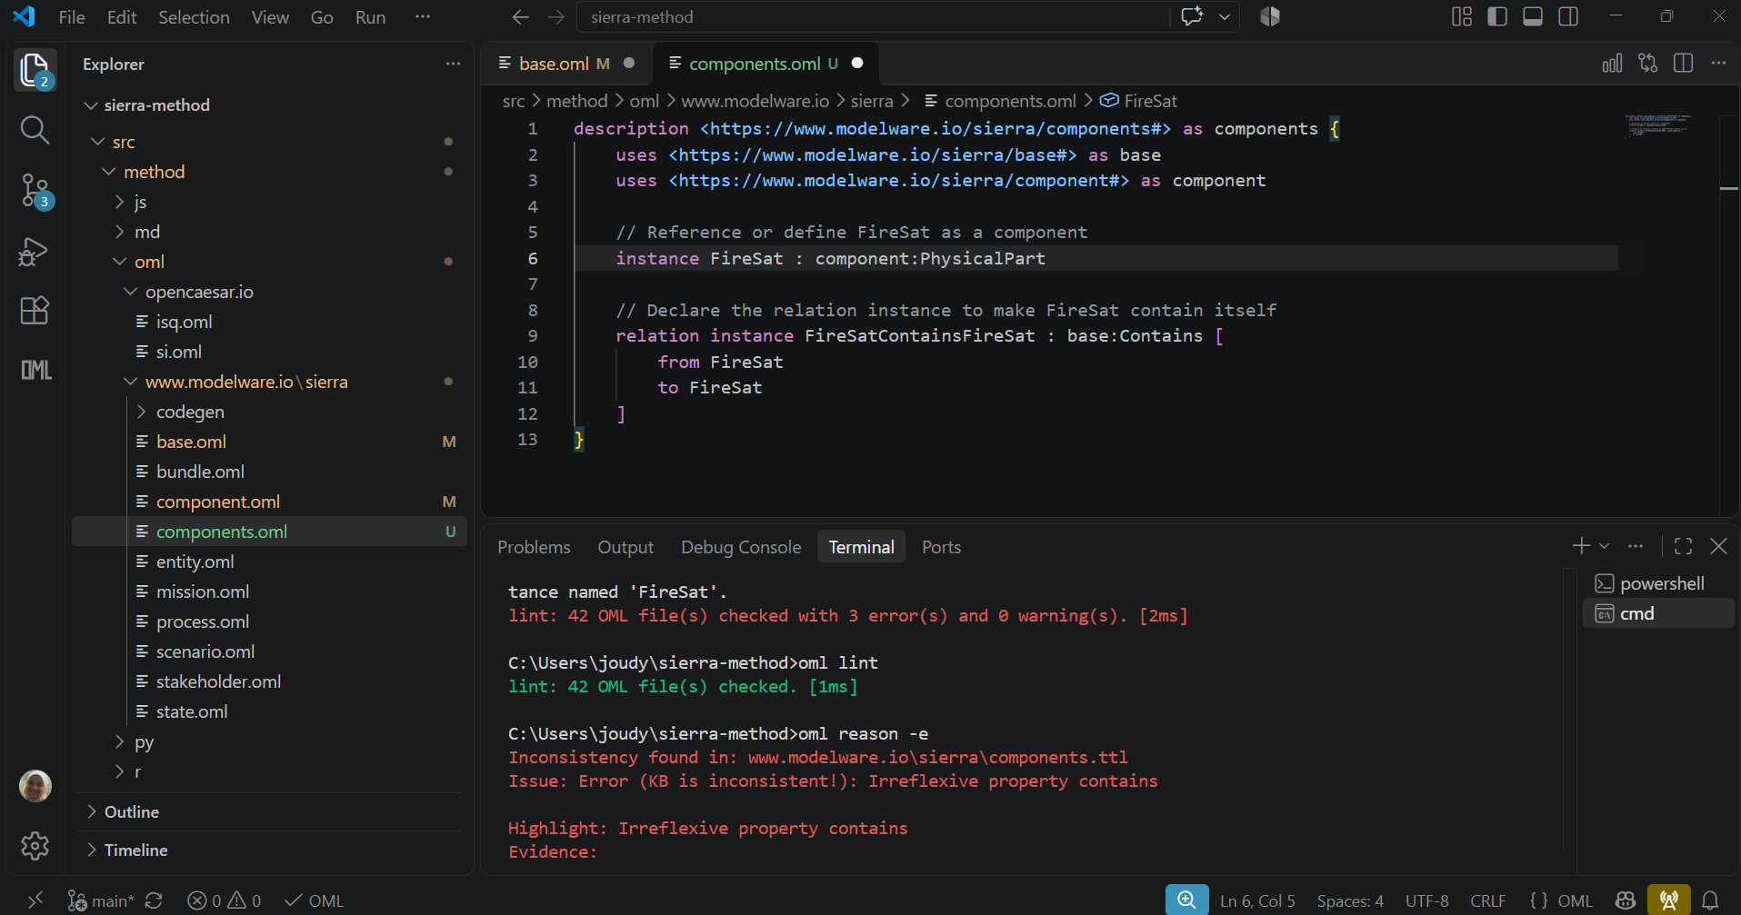
The reasoner reports that the ontology is inconsistent, so the run should fail with an error because irreflexive forbids any individual from being related to itself by contains. Your assertion makes FireSat contain itself, which contradicts that axiom, so the reasoner can’t find a consistent model.
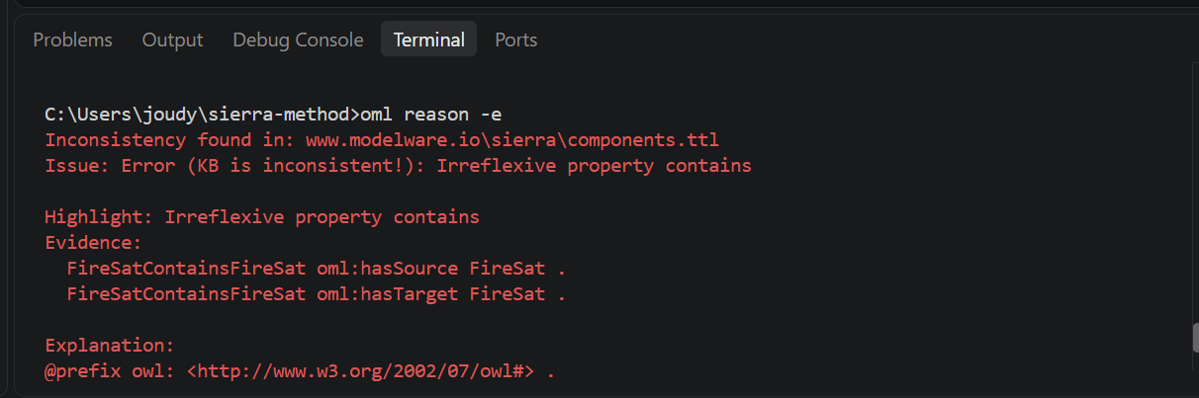

Add Component:Signal to ElectricalPower
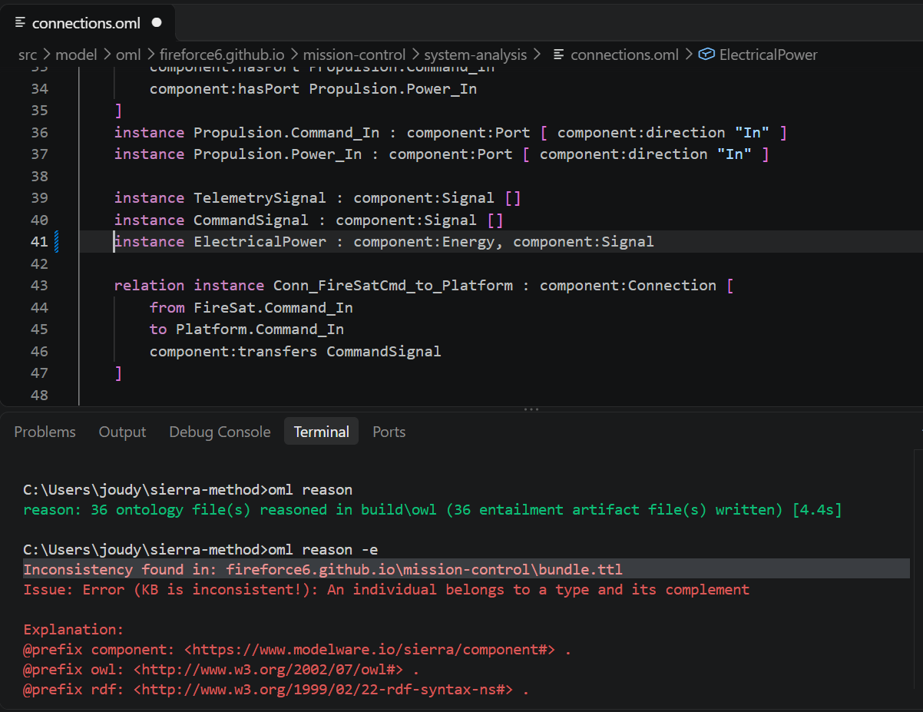
Because Energy and Signal are distinct concepts inheriting from base:Item in vocabulary, OML treats them as disjoint by default. Assigning both types to ElectricalPower is a contradiction, and the reasoner reports an inconsistency.
Bundle Comment:
Without the component vocabulary bundle active, the reasoner no longer knows that Energy and Signal are disjoint concepts defined under that namespace. As a result, the disjointness error disappears
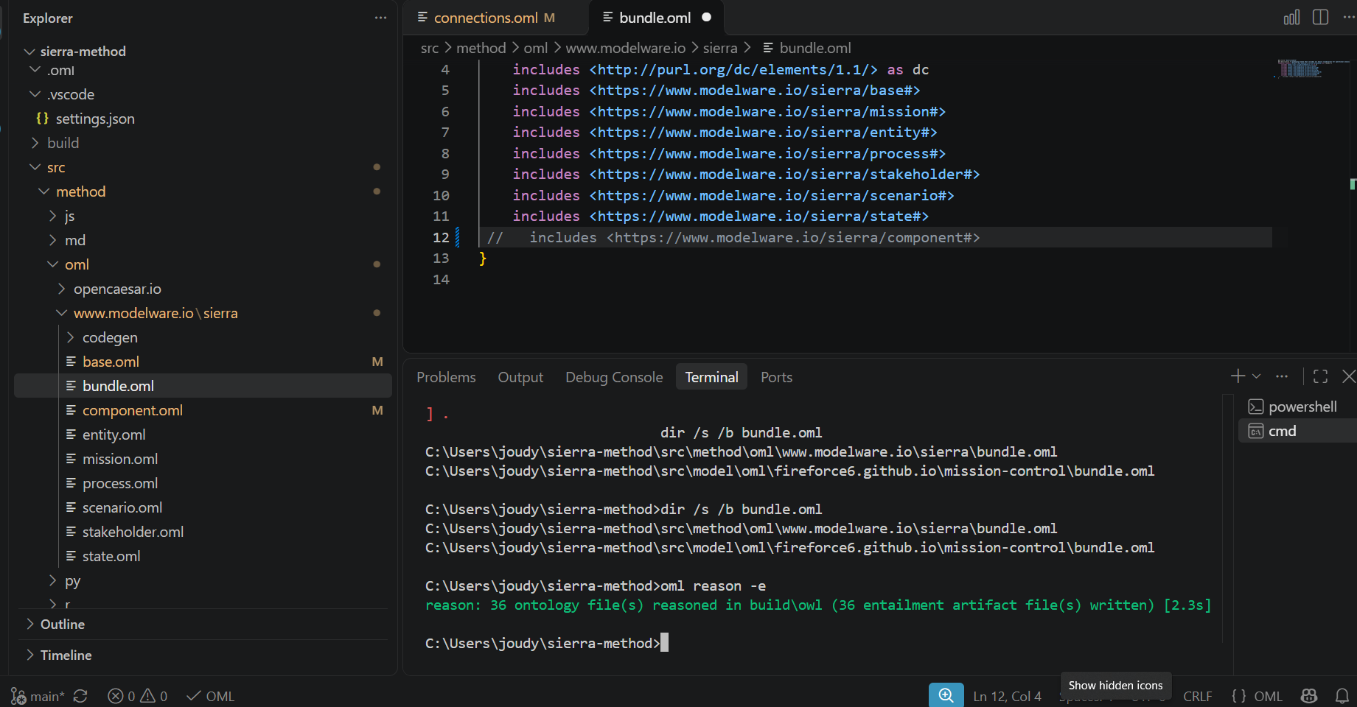

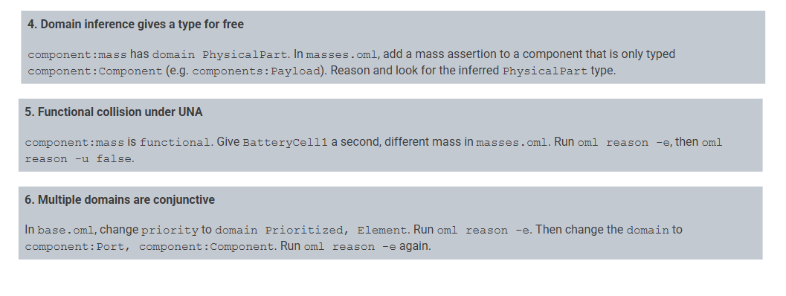
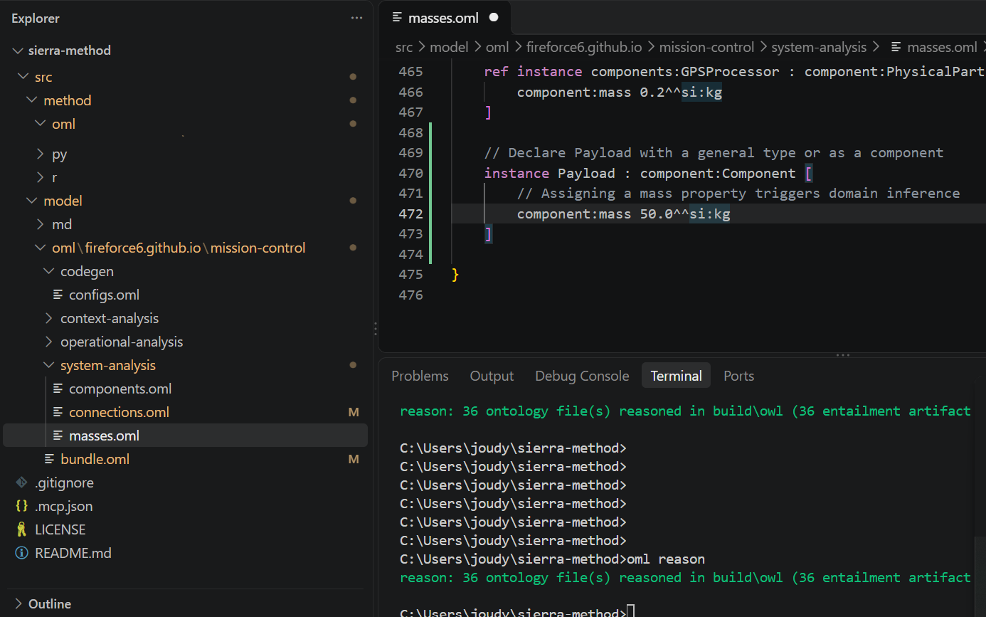
Added payload mass and the reasoner inferred that it belongs to component:PhysicalPart because the mass property restricts its domain to PhysicalPart.
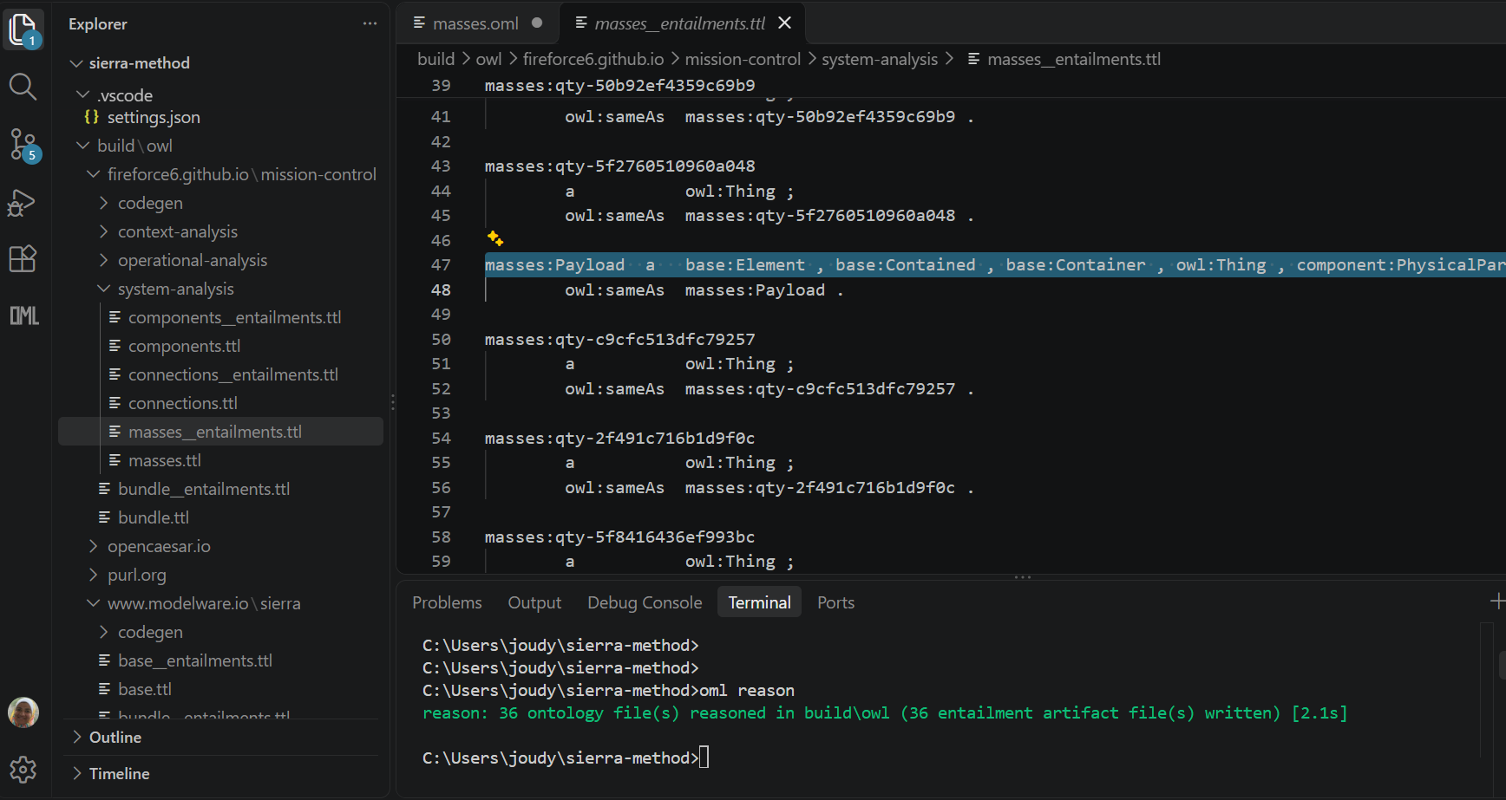

Add another mass value 10 kg to Battery Cell #1:
Because component:mass is functional, assigning two different values (10.0 and 14.5) to the same instance (BatteryCell1) creates a functional clash and the reasoner flags this as an inconsistency in the first screenshot.
In the second screenshot (with -u false), the reasoner treats distinct values as non-unique under specific conditions, allowing it to bypass the functional collision depending on the entailment configuration.

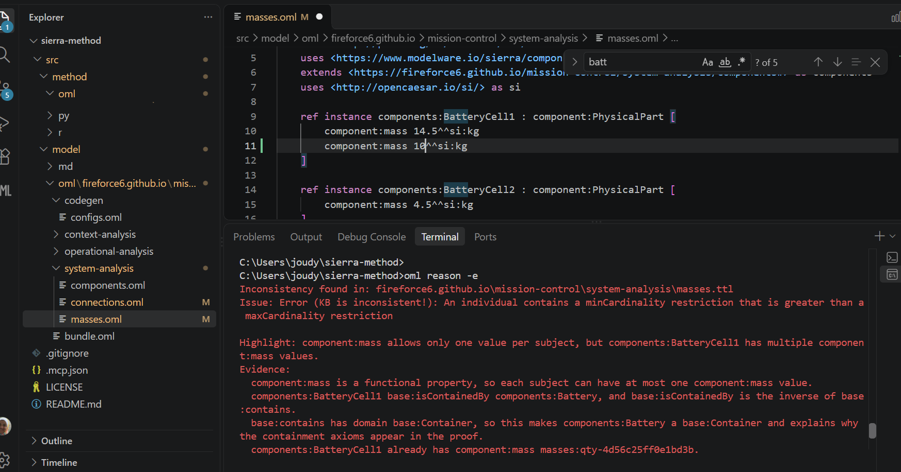
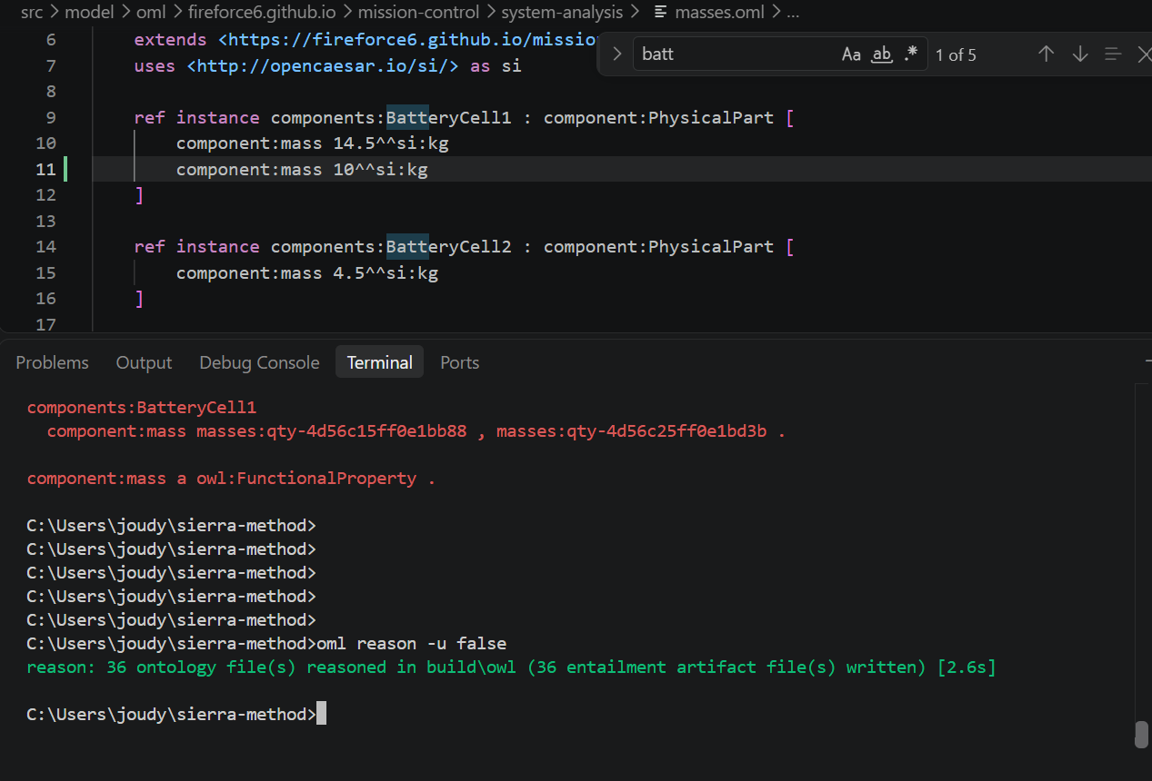
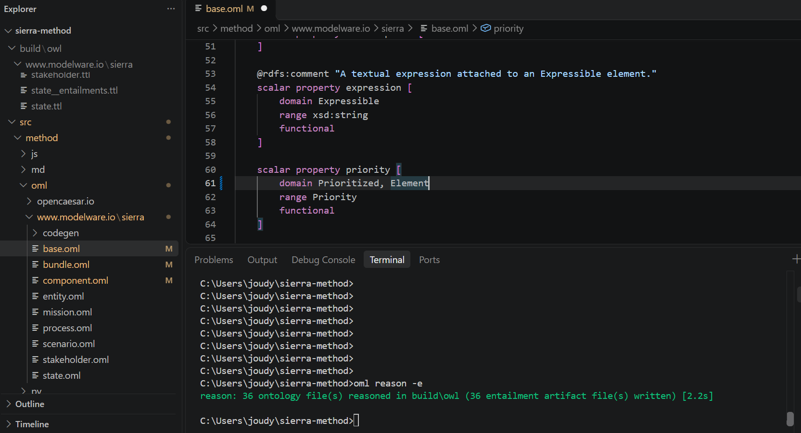

Because multiple domains in OML are conjunctive (meaning the subject must belong to both domains simultaneously—i.e., the intersection), any element assigned a priority is inferred to be both a Prioritized and an Element (everything already inherits from Element)

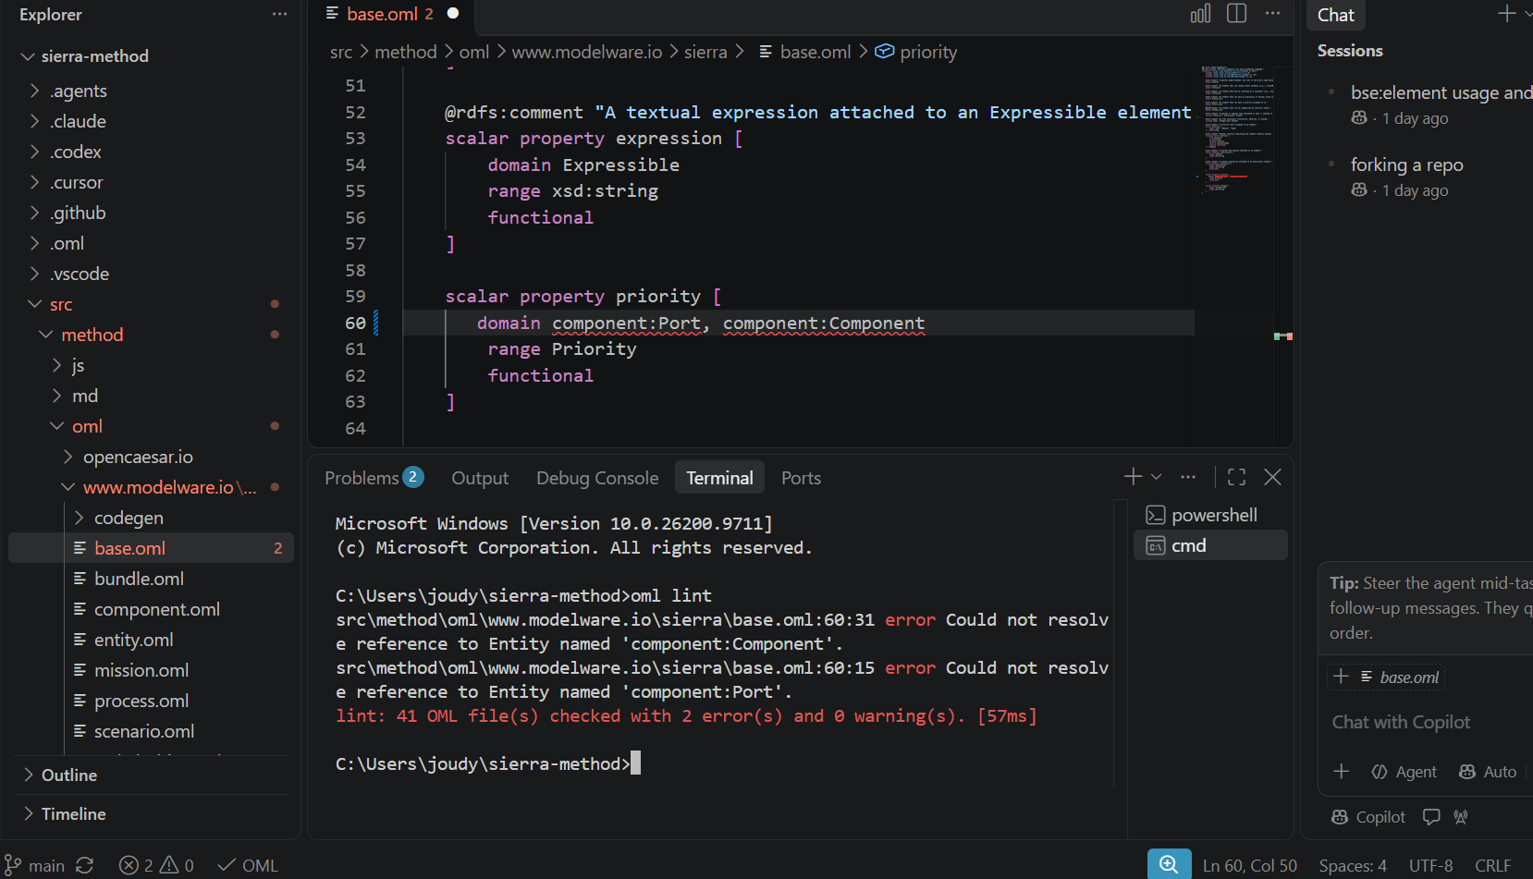
Attempting to reference component entities in base.oml triggers a linter resolution error due to OML's cross-layer scoping limits and circular dependency prevention.

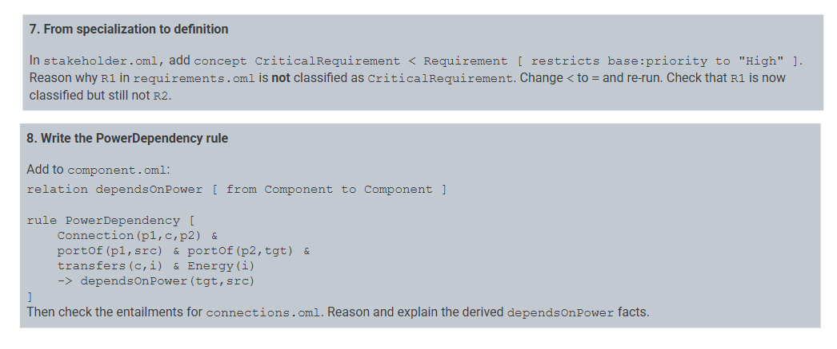
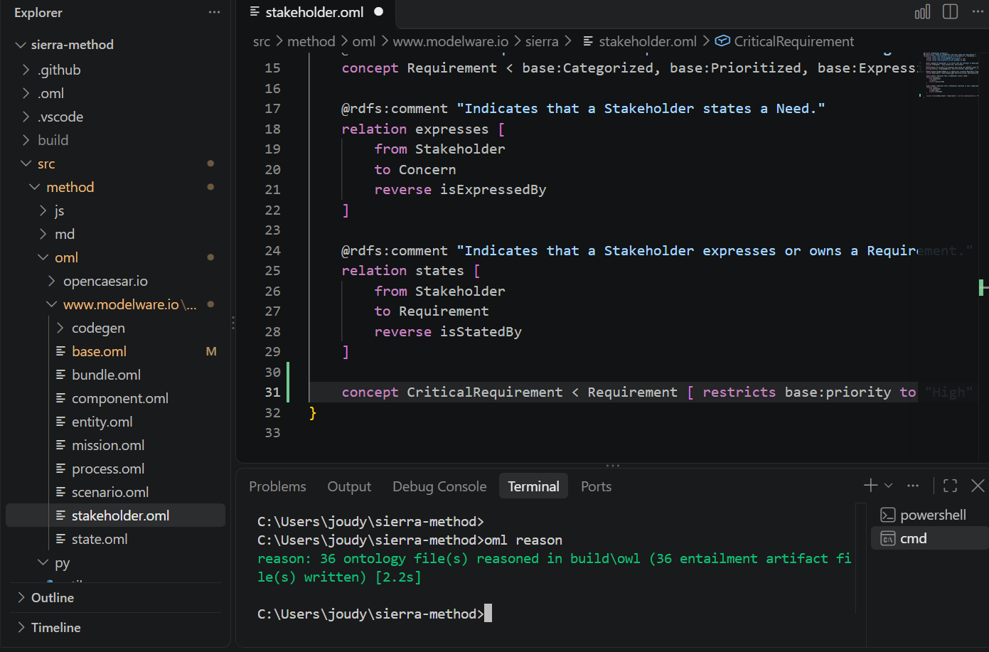
The reasoner understands that if an instance is a CriticalRequirement, it must have a high priority. However, it does not automatically infer the reverse, i.e. meaning a generic Requirement with a high priority (R1) is not automatically classified as CriticalRequirement.
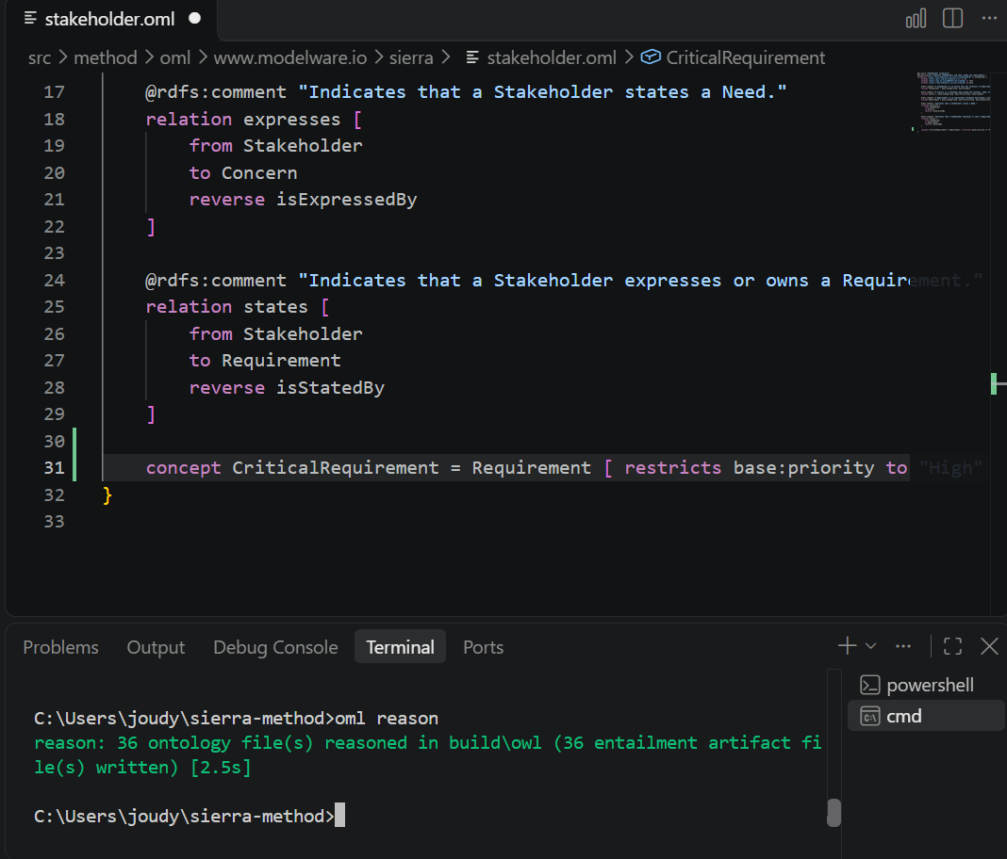

- Why R1 IS classified: Changing < to = defines CriticalRequirement as a defined concept . Any requirement instance that satisfies base:priority "High" (such as R1) is automatically recognized and classified by the reasoner as a CriticalRequirement.
- Why R2 is STILL NOT classified: R2 has base:priority "Low", so it fails the restriction criteria ("High"), keeping it outside the CriticalRequirement classification.
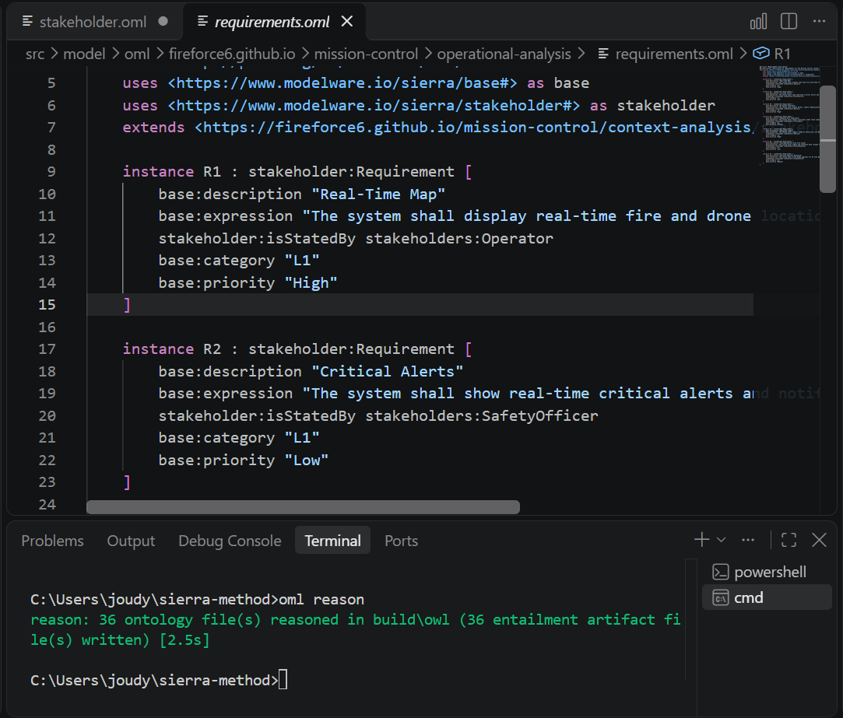
When the reasoner executes this rule over connections.oml description bundle, it performs the following logic:
- Finds Connections & Ports: It identifies any connection c between two ports p1 and p2.
- Resolves Components: It looks up which components own those ports via portOf(p1, src) and portOf(p2, tgt).
- Filters by Energy: It checks if the connection transfers an item i that is typed as an Energy concept (transfers(c, i) & Energy(i)).
- Infers the Dependency: If all conditions are met, the reasoner automatically derives and entails that the target component depends on the source component for power: dependsOnPower(tgt, src).



